

**DINING SCHEDULER**

Contents

**Acronyms** 4

**Scenario** 5

**Statement of need** 5

**Team name: Incredibles** 5

**Team members** 5

**Team Meeting** 5

**Contacting** 5

**Knowledge Areas and their artifacts** 5

**Project Charter** 7

**Project Objectives** 7

**Success Criteria** 7

**Approach: Agile Approach** 7

**Stakeholder Register for Dining Scheduler** 8

**Project Management Plan** 9

**Management and Technical Processes** 9

**Scope Statement** 11

**Project Time Management** 12

**Project Cost Management** 13

**Quality Management Plan** 14

**Staffing Management Plan** 16

**Dining Scheduler Organizational Chart** 16

**Communication Management Plan** 17

**Risk Management Plan** 19

**Risk Mitigation** 21

**Procurement Management Plan** 22

**Contract Statement of Work** 24

**Request for proposal- Dining Scheduler** 26

**Stakeholder Management Strategy for E-Pharma** 27

**Stakeholder Register for Dining Scheduler** 28

**Issue Log** 29

**Acronyms**

|  |  |
| --- | --- |
| **Acronym** | **Full form** |
| OTT | Out Thinkers Technology |
| CEO | Chief executive officer |
| IT | Information Technology |
| WBS | Work breakdown structure |
| RFP | Request for proposal |
| ISO | International Organization for Standardization |
| QMS | Quality management system |
| PMBOK | Project Management Body of Knowledge |
| HR | Human Resources |
| SLA | Service level agreement |
| IOS | iPhone operated system |
| SQL | Structured query language |

## **Scenario**

Out Thinkers Technology is a reputed software company in Swedish IT market for scheduling timings for dining. Most of their products are compatible with all types of devices. The client has asked Out Thinkers Technology(OTT) to develop an application which takes their part-time employees schedule and assigns shifts to the employees in their available timings.

## **Statement of need**

It is an application which is useful to schedule shifts for part time employees-based employee available timings.

## **Team name: Incredibles**

## **Team members**

1. Alekya Billakanti
2. Hema Sree Rathnam Machha
3. Hemanth Venkata Reddy Telluri
4. Jaya Kumar Saga
5. Shiva Ram Kothapally

**Client:** Dr.Aziz Fellah

## **Team Meeting**

Our team meets on Google hangouts online meeting site to keep track of the project on Every alternative day from 3:00PM to 5:30 PM. In the team online meeting, we will discuss the progress of the work and difficulties faced during the project.

## **Contacting**

The team shall stay in contact through e-mails and hangouts for Business. When there is emergency, we shall contact the team member using their personal mobile number.

## **Knowledge Areas and their artifacts**

1. Project Integration Management
   * Project Charter: A project charter is the statement of scope, objectives and people who are participating in a project. The charter also identifies the main stakeholders and defines the authority of the project manager.
   * Project Management Plan: A Project management plan is a formal, approved document that defines how the project is executed, monitored, and controlled. This document is used to define the approach project team takes to deliver the intended project management scope of the project.
2. Project Scope Management
   * Requirement Management Plan
   * Requirement’s specifications Document
   * Scope Management Plan
   * Scope Statement
   * Work Breakdown Structure
3. Project Time Management
   * Schedule management plan
     + Gantt charts
4. Project Cost Management
   * Cost management plan
     + Cost estimation and determine budget.
5. Project Quality Management
   * Quality management plan
     + Items included for Quality control.
     + Benchmarking against other products or projects
     + Measurement regarding types of defects
6. Project Human Resources Management
   * Human resources management plan
     + Project organizational charts
     + Responsibility assignment matrices
     + Resource histograms
7. Project Communications Management
   * Communication management plan
     + Stakeholder Communication analysis
8. Project Risk Management
   * Risk management plan
     + Risk register
     + Risk mitigation strategies
9. Project Procurement Management
   * Procurement management plan
     + Statement of Work
     + Request for proposal
10. Project Stakeholder Management
    * Stakeholder management plan
      + Stakeholder register
      + Stakeholder analysis
      + Issue log
    * Final Presentation

## **Project Charter**

Project Title: Dining Scheduler

Project Start Date: 05-17-2021

Projected Finish Date: 06-03-2021

Budget Information: Self-sponsored

Project Manager: Hema Sree Rathnam Machha

## **Project Objectives**

Developing an application which helps scheduling an employee’s shift.

## **Success Criteria**

Meeting triple constraints (scope, time, and cost) and customer satisfaction. It is an application which is useful for scheduling shift for an employee. Employee can view his shift timings and update his timings. This will reduce amount of human effort required for scheduling.

## **Approach: Agile Approach**

**Roles and Responsibilities**

|  |  |  |  |
| --- | --- | --- | --- |
| ***Name and Signature*** | ***Role*** | ***Position*** | ***Contact Information*** |
| Alekya Billakanti | Team Member | Tester | [S542388@nwmissouri.edu](mailto:S542388@nwmissouri.edu) |
| Hema Sree Rathnam Machha | Project Manager | Manager | [S542270@nwmissouri.edu](mailto:s542270@nwmissouri.edu) |
| Hemanth Venkata Reddy Telluri | Team Member | Application Developer | [S542393@nwmissouri.edu](mailto:S542393@nwmissouri.edu) |
| Jaya Kumar Saga | Team Lead | Full Stack Developer | [S542392@nwmissouri.edu](mailto:S542392@nwmissouri.edu) |
| Shiva Ram Kothapally | Team Member | Web application developer | [S542269@nwmissouri.edu](mailto:S542269@nwmissouri.edu) |

## **Stakeholder Register for Dining Scheduler**

**Prepared by:** Hema Sree Rathnam Machha **Date:** 05/07/2021

|  |  |  |  |  |
| --- | --- | --- | --- | --- |
| **Name** | **Position** | **Internal/External** | **Project Role** | **Contact Information** |
| Alekya Billakanti | Tester | Internal | Team Member | [S542388@nwmissouri.edu](mailto:S542388@nwmissouri.edu) |
| Hema Sree Rathnam Machha | Manager | Internal | Project Manager | [S542270@nwmissouri.edu](mailto:s542270@nwmissouri.edu) |
| Hemanth Venkata Reddy Telluri | Application Developer | Internal | Team member | [S542393@nwmissouri.edu](mailto:S542393@nwmissouri.edu) |
| Jaya Kumar Saga | Full Stack Developer | Internal | Team Lead | [S542392@nwmissouri.edu](mailto:S542392@nwmissouri.edu) |
| Shiva Ram Kothapally | Web application developer | Internal | Team member | [S542269@nwmissouri.edu](mailto:S542269@nwmissouri.edu) |
| Dr. Aziz Fellah | End User | External | Client | AFELLAH@nwmissouri.edu |

## **Project Management Plan**

**Project Name:** Dining Scheduler

**Introduction/Overview of Project**

Out Thinkers Technology is a reputed software company in Swedish IT market for scheduling timings for dining. Most of their products are compatible with all types of devices. The client has asked Out Thinkers Technology(OTT) to develop an application which takes their part-time employees schedule and assigns shifts to the employees in their available timings.

**Project Organization**

The observed organizational structure in OTT company is Matrix structure as it has dual or multiple managerial accountability and responsibility. Each person is given authority to his area of work and needs to report to the person who is in a level above him.

## **Management and Technical Processes**

**Management Processes:**

People from various levels in Management are involved in delivering the project. Highest priority is given to delivering the project on time and within the available budget. Management decides if a change request should be approved or not and keeps a check on the monthly status.

**Assumptions, Dependencies, and Constraints:**

Team members assumed that application has no special accommodations required unless the client comes up with something new. The application has a user interface. The project must satisfy the triple constraints: scope, quality, and time.

**Risk Management:**

The root cause of the risk must be identified to avoid any other future affects due to the risk. Risk management team should come up with new strategic plans and mitigation plans.

Monitoring and Controlling Mechanisms:

* Monitoring of the project includes collecting, measuring, and disseminating performance. All the deliverables of the project will be monitored.
* Project management plan will include a starting point, a measurement, or an observation that is documented so it can be used for future.

Staffing Plan:

All the staff included for project are from various domains and areas of expertise like database administrator, testing, data analyst, software developer and project manager.

**Technical Processes:**

Methods, Tools, and Techniques:

Technologies used for the application are Java, Oracle and for developing the frontend HTML, JavaScript. For preparing documents Microsoft Office Suite.

Software Documentation:

All the standards were followed while creating the documents. All the team members strictly follow these standards and need to be reviewed by management.

Project Support Functions:

The project is supported by management plans, and daily sprint meeting will be conducted to review the progress. By monitoring the project on regular basis, the project will be within time, scope, and budget.

**Work to Be Performed**

Work Packages:

Work packages include all the deliverable artifacts which covers all the tasks phase wise in the project. These include all the documents, developing the software application and its packages. Testing team will test the application with all the possible test cases and test case documents will be given to the developers.

Dependencies:

A delay in one of the tasks will have effect on the coming phases. To avoid this all the tasks, need to be completed within given time,

Resource Requirements:

Each resource in the ream requires a machine and a workplace. We will need 6 windows machines that include developer’s and testers. All the resources costs are considered in the budget.

**Schedule Information**

The project has been started on 18/05/2020 and will end on 06/02/2020. The project management plan has a detailed schedule of the project.

**Budget Information**

The budget of the project is $300,000. The project manager will accordingly allocate the budget to each of department, depending on the number of resources, usage, roles, responsibilities including technical equipment.

**References to Other Project Planning Documents**

We have referenced many articles to know about how a project can be made more successful. We have studied the most outcomes of the successful projects and we will try to implement them in our project.

## **Scope Statement**

**Project Justification:**

Out Thinkers Technology is a reputed software company in Swedish IT market for scheduling timings for dining. Most of their products are compatible with all types of devices. The client has asked Out Thinkers Technology(OTT) to develop an application which takes their part-time employees schedule and assigns shifts to the employees in their available timings.

**Product Characteristics and Requirements:**

1. The application must store schedule of all part time employees.
2. The application must allocate shifts to all part time employees.
3. It should not allocate more than 20 hours to any part timers.
4. The system must be accessible to all the employees.

**Project User Acceptance Criteria**

The product must be delivered to client without any delay. The Product must meet all the functionalities and it must be of user-friendly interface.

**Summary of Project Deliverables**

**Project management-related deliverables:** Business case, charter, team contract, scope statement, WBS, schedule, cost baseline, status reports, final project presentation, final project report, lessons-learned report, and any other documents required to manage the project.

**Product-related deliverables:** research reports, design documents, software code, hardware, etc.

1. An application prototype in which it demonstrates how the application will look and work.
2. An application which allocates shifts to all employees.
3. A user-friendly user interface which helps employees to update their schedule.

Finalized analysis and business solution.

## **Project Time Management**

**Schedule Management Plan**

Here is a screenshot of WBS spreadsheet:

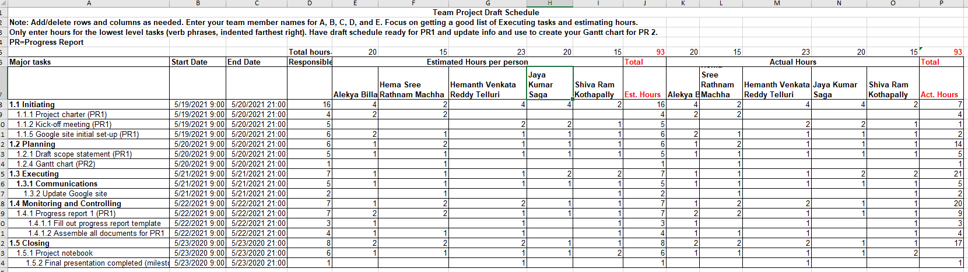

Here is the screenshot of Gantt chart of our project:

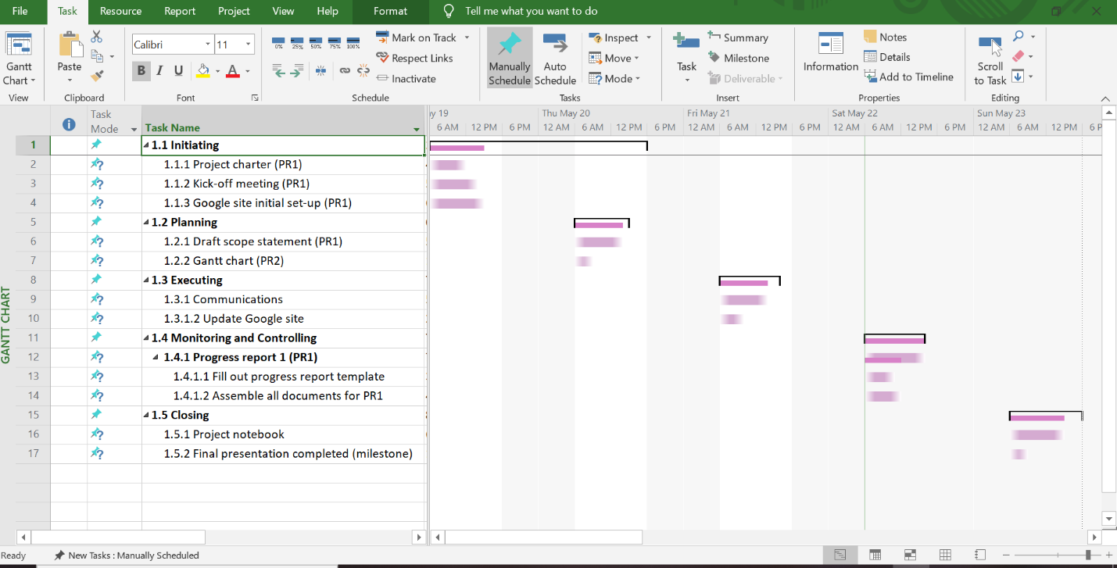

## **Project Cost Management**

**Level of accuracy:**

We rounded the cost estimates to the nearest $100.

Level of accuracy for activity cost and contingency funds is 90 percent.

**Units of measure:**

Cost estimation is done in US Dollars.

**Organizational Procedures links:**

We use the WBS as a framework to provide the stability with estimates.

1. **Control thresholds:**

Change requests during programming might increase the project budget than estimated cost. Implementing the change requests may cost more than the estimated cost. - 10 percent of Variance allowed.

1. **Reporting formats:**

A month-to-month project status report will be submitted about the expense sensible. Every one of the remedial activities required in the expense the executives plan is accounted for in this record. This segment depicts the configuration and recurrence of cost reports needed for the undertaking. This part would depict the arrangement and recurrence of cost reports needed for the venture. Reports are extremely valuable for following advancement and accomplishment of undertakings. Choosing of cost announcing designs assumes a significant part to show reports. It is smarter to utilize great detailing organizations to show cost data adequately.

1. **Process Descriptions:**

Description of all the processes in cost management is documented.

**Note:** Cost estimation and determine budget is attached to the document.

## **Quality Management Plan**

**Introduction:** Quality is most important for any product to be successful in market. Quality of their products makes Out Thinkers Technology(OTT) one of the most reputed Organization in Swedish IT market. The company has currently acquired the project to develop quality check equipment which can use by both mobile application and web applications. The client has asked OTT to develop an application which to develop an application which takes their part-time employees schedule and assigns shifts to the employees in their available timings. The project manager has overall responsibility for the quality management process. Some projects may also have specific roles for a quality assurance person or quality experts.

**Quality Standards:** ISO 9001 is the internationally recognized Quality Management System (QMS) standard that can benefit any size organization. According to A Guide to the Project Management Body of Knowledge (PMBOK® Guide), quality is “the degree to which a set of inherent characteristics fulfill requirements.

Quality standards are defined as documents that provide requirements, specifications, guidelines, or characteristics that can be used consistently to ensure that materials, products, processes, and services are fit for their purpose.

**Metrics:** is a unit for measuring different factors like accuracy, consistency, failure rates, availability, response time, reliability, etc. This project management tool generates a real-world value as a measurement. It also establishes a tolerance value for the metric's permitted variances. The quality metric is used to measure the cost of the deliverable to estimate the percentage deviation from the budget, for example, if the objective falls within the budget by 20%. In the control quality measurements are used.

Below metrics are used for our project:

* **Productivity** – This metric allows project managers to assess the utilization of resources. It compares the total effort to the budgeted effort, which has a direct impact on the bottom line. Delays in the timeline, underperformance by staff or vendor and unavoidable circumstances can all impact the productivity metric.
* **Scope of Work** – A project’s scope is typically established right up front, but changes and additions can derail even the best project manager’s efforts. Tracking change requests is necessary, to control them and keep the project on time and budget.
* Quality and Satisfaction – Quality assurance is a truly customer-focused metric. Assuring low defects throughout the project, as well as a quality deliverable at its end, should be part of every project. Catching defects early can also help prevent the entire project from losing focus and failing.
* **Cost** – Measuring how costs are managed is often critical to a project’s success. Cost management is related to other variables, such as quality, scope, and productivity, so if it varies above or below projections, the project can suffer. Ideally, cost is closely monitored throughout the project so if costs rise unexpectedly, variables such as scope or time are adjusted, and the project can still achieve its objectives.
* **Gross Margin** – Typically, a project’s goal is to contribute to the organization by increasing profits. The gross margin is the difference between total income achieved and total costs spent on the project. A project should have a target gross margin established in the planning stages, and it should be measured throughout. Project managers who achieve or exceed target gross margins are often extremely valuable.

**Problem Reporting and Corrective Action Process**

Project managers are tasked with the challenging job of juggling needs and resources that are sometimes beyond their direct control to generate the required project deliverables within the constrained timeframes they must adhere to (scope, time, quality, etc.). Even if the ideal project plan could be created and implemented, it would not eliminate all the hazards that could potentially affect a project.

There are three major activities focused on minimizing potential risks that occur during the phases of a project. The first risk reduction activity occurs during project planning, when a proactive risk assessment is performed and the detected risks are either mitigated or avoided (for example, by revising the project plan), transferred (for example, through insurance), or accepted (by doing nothing).

The second activity is to analyze risk on a continuous basis throughout the project. The final risk-reduction activity is to organize a retrospective "lessons learned" session at the end of the project, which will have the least impact on the current project but will benefit upcoming projects.

**Supplier Quality and Control**

Supplier quality is a supplier’s ability to deliver goods or services that will satisfy customers’ needs. Supplier quality management is defined as the system in which supplier quality is managed by using a proactive and collaborative approach.

Control charts are primarily used to avoid issues rather than to find or reject them. You can use quality control charts to see if a process is under control or out of control. Any differences in a process's results are caused by random events while it is in control processes that are in control do not need to be altered.

## **Staffing Management Plan**

**Introduction:**

Creation of a software Application which helps in scheduling the working hours of an employee. Application can be used wherever there is a requirement to schedule working hours to employee working at different times as per there availability.

**Staffing Requirements:**

This project will require the following internal staff:

* Project Manager who is responsible for the team.
* Project team members from HR department and technology department for technical support.
* Personnel from the informational department for software and hardware training.
* Project management team to assist with project management education.
* Personnel from the contracting department to assist with project contracts.

**Staff Assignments:**

Individuals will be assigned to the project by the project manager in collaboration with functional managers. The project manager conducts a suitability interview with possible candidates. If a specific skill set is required for the project, the functional managers will assist in obtaining that skill set. Employees will be compensated overtime if necessary.

**Training, Rewards, and Reassignment**

Employees hired for this project must have relevant experience or the ability to learn quickly and work efficiently. Employees hired for this project must have relevant experience or the ability to learn quickly and work efficiently. Employees' performance is evaluated, and appropriate points are rewarded for finished work. If an employee is not performing well, the project manager is responsible for making any necessary modifications and reassigning the project.

## **Dining Scheduler Organizational Chart**

Here is the screenshot of Organizational chart of our project:

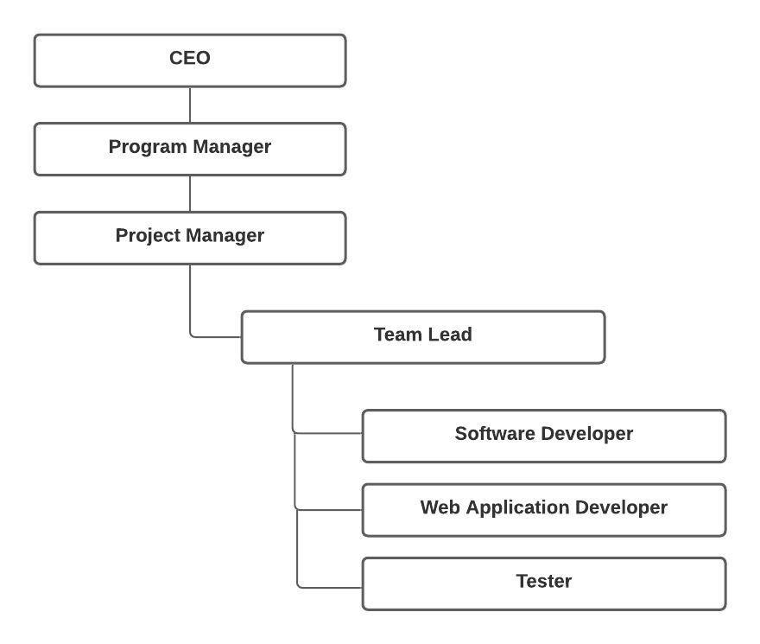

## **Communication Management Plan**

1. **Stakeholder communications requirements:**

|  |  |  |  |  |
| --- | --- | --- | --- | --- |
| **Stakeholders** | **Document Name** | **Document Format** | **Contact Person** | **Due Date** |
| Program Manager | Project status report | Email | Hema Sree Rathnam  Machha S542270@nwmissouri.edu | Every week |
| Application Developer | Project status report | Email | Hemanth Venkata Reddy Telluri S542393@nwmissouri.edu | Every week |
| Team member | Project documents | Email | Alekya Billakanti S542388@nwmissouri.edu | Daily |
| Team member | Project documents | Email | Jaya Kumar Saga S542392@nwmissouri.edu | Daily |
| Team member | Project documents | Email | Shiva Ram  Kothapally  S542269@nwmissouri.edu | Daily |
| Sponsor | Budget analysis report | Report | Dr. Aziz Fellah  AFELLAH@nwmissouri.edu | One month before project commences |

1. **Communications summary:**

|  |  |  |  |  |
| --- | --- | --- | --- | --- |
| **Stakeholders** | **Communications Name** | **Delivery Method/Format** | **Producer** | **Due/Frequency** |
| Project steering committee | Weekly status report | Hard copy and short meeting | Hema Sree Rathnam  Machha | Monday. mornings at 10 AM |
| Sponsor and champion | Monthly status report | Hard copy and short meeting | Hema Sree Rathnam  Machha | Last Friday of month at 10 AM |
| Affected employees | Project announcement | Memo, e-mail, intranet site, and announcement at department meetings | Jaya Kumar Saga and Shiva Ram Kothapally | May 1, 2021 |
| Project team | Weekly status report | Short meeting | All team members | Tues. 4:00 PM. |

1. **Comments/Guidelines:** The project information can be collected through different processes such as interviewing, face-to-face interactions and through productive meetings. Confidential project information can be stored in secure tool such as google tools that allows easy access to all the stakeholders.
2. **Escalation procedures for resolving issues:** The issues need to be systematically resolved by raising tickets and resolving based on priorities without missing SLAs. Any project stakeholder with issues must create a formal report and submit it to the appropriate project team member. If necessary, the report's recipient will discuss the problem with the Project manager and other team members. The team makes the necessary changes to remedy the issue if the Project Manager approves.
3. **Revision procedures for this document:** The project team will decide on updating the Communications Management Plan if needed during the weekly meetings. If any changes are required, the project manager will discuss the changes with the relevant stakeholders before carrying them out.
4. **Glossary of common terminology:**

Stakeholder – An individual, group, or an organization, who may affect, be affected by, or perceive itself to be affected by a decision, activity, or outcome of a project.

Escalation – Escalation in project management is an anticipated rise in uncommitted costs of resources (labor, material, equipment) over time, due to reduced purchasing power of money.

## **Risk Management Plan**

**1. Methodology:**

Our project's risk management process is designed to assist, educate, and reduce project hazards. The risk model is based on the presence of one or more causes with a low likelihood of conflict, as well as one or more consequences that will increase because of the event's occurrence. In practice, a reactive method is used to flag both known and unknown threats.

**2. Roles and responsibilities:**

The Risk Management Plan must be signed and approved by the Project Manager, who must also decide the risk management strategy, participate in the risk management process, and take charge of risk reduction, preparation, and execution.

The Risk Officer is responsible for administering the risk management application, sponsoring risk identification activities, assisting with ideas during the risk management process, and ensuring the Risk Register is created and risk rankings are given. The Risk Officer oversees providing support and status on risk actions to the Project Manager.

**3. Budget and schedule:**

The goal of incorporating risk management into budget planning is to understand the premises upon which your budget is built.

Risk analyzing a full budget may appear to be a daunting endeavor, but the best approach to proceed when addressing the risks of any subsequent process is to separate it into portions and focus on those with the largest potential impact. The risk management team keeps the budget and schedule under control on a regular basis to respond quickly to hazards and avoid extra losses.

**4. Risk categories:**

Strategic risk, technical risk, financial risk, market risk, compliance risk, and many other types of risks might occur in a project.

**5. Risk probability and impact:**

Probability: A risk is a situation that has the potential to occur. The chances of it happening range from little over zero percent to just under one hundred percent.

Impact - Risk, by definition, has a negative impact. However, the magnitude of the influence varies in terms of cost and influence on health, human life, or any other critical component.

**6. Risk documentation:**

Everything related to documentation is preserved on a hard drive and is updated on a regular basis. During team meetings, hard copies are distributed. During our project, we employed soft copies to make things easier.

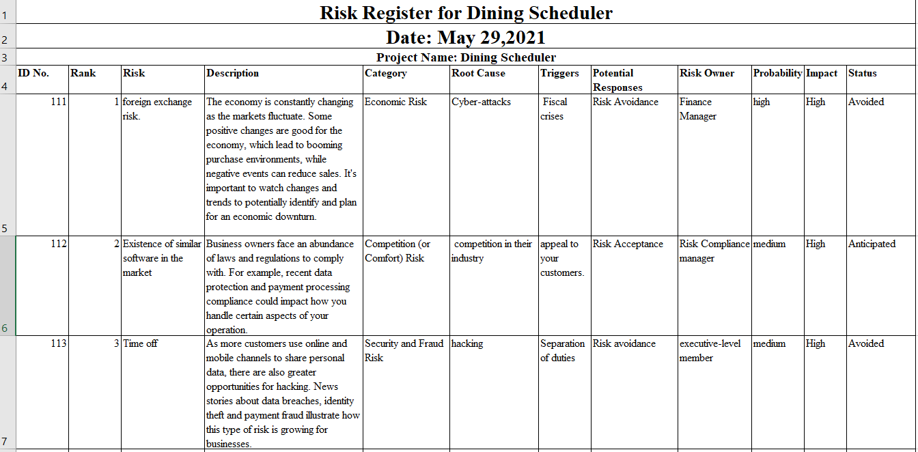

## **Risk Mitigation**

**Introduction**

As the project risks are identified throughout the project, the Project Manager and Team Lead will access them and build avoidance and mitigation strategies with the project team. These risks are used to update the Risk Register and the risk management plan, ensuring that these risks are tracked and addressed to in a timely manner.

With the constraints of time, scope, and cost, both identified and future project risks will be managed and controlled. With the assistance of the Team Lead, the Project Manager will determine the best approach to respond to each risk to ensure compliance with these constraints.

In the worst-case situation, one of the project's limitations may need to be made flexible. If extra resources are required to meet the project's schedule and scope, further funding may be added to the project. Time and scope are project constraints that do not allow for any flexibility. However, in extreme cases where no other risk avoidance or mitigation method will work, cost constraints will be allowed to be flexible.

**Risk Mitigation Strategies:**

|  |  |  |  |
| --- | --- | --- | --- |
| **Risk Rank** | **Major Risks** | **Strategies to mitigate risks** | **Responsibility** |
| 1 | Economic Risk | Economic risk can also be mitigated by investing in insurance | Finance Manager |
| 2 | Competition (or Comfort) Risk | Set competitive pricing. | Risk Compliance manager |
| 3 | Security and Fraud Risk | Mitigate fraud risks by preventing nefarious actors from gaining access to your data in the first place. | executive-level member |
| 4 | Financial Risk | strong balance sheet can also lead to the potential for investment in your business | Finance Manager |
| 5 | Reputation Risk | 1. Understand stakeholder expectations. | Organization |

## **Procurement Management Plan**

**Guidelines on Types of Contracts:**

Contracts for using certain commodities and services on a project are known as procurement contracts. Fixed-value, cost-reimbursable, or time-and-materials contracts are the most common types of procurement contracts. On a single purchase, certain agreements may include more than one of these payment schemes.

The executive acquisition process enables you to get the best temporary workers and service suppliers for the products and initiatives you need for your project. Because each type of procurement contract comes with its own set of benefits and downsides, choosing the right one can have a considerable impact on the success of a project.

**Standard procurement documents or templates:**

* **Minor/Low Risk Contracts:** In this type of contract, an organization need administrations for a short amount of time, and the work is often tedious. As a result, top-of-the-line board methods aren't required for this type of arrangement.
* **Major/High Risk Contracts:** The labor required here is becoming increasingly difficult, necessitating the use of more advanced administration approaches.
* **Professional:** This necessitates a higher level of information-based skill, as well as directors who are willing to devote greater time and effort to finding new knowledge in order to meet the client's expectations.
* **Facilities:** Typically, the labor dispersed in this type of administration is the upkeep or activity of an existing structure or framework.
* **Local/Simple Purchases:** Goods are more readily available, and hence the board of the purchasing and delivery process is not required.
* **International/Complex Purchases**: In this case, products from several regions should be obtained. The job of an administrator is becoming increasingly taxing, and a management technique is required to purchase and deliver. Similarly, the supervisor must look into cross-border customs.

**Guidelines for creating procurement documents**:

A procurement document must have a large number of reports that serve as invitations to delicate, requests for delicate foffers, and establish the terms and conditions of a contract. The purchaser's first offer and the monetarily party in question's request for concessions.

Requests for data between two gatherings, as well as requests for citations and recommendations, as well as the response of the dealer, should all be included in the procurement documentation.

1. Potential bidders must give all business specifics in order for the bidder to be evaluated.
2. In order to be evaluated, potential bidders must provide full business details.Clear meaning of the duties, rights and responsibilities of the two gatherings in the agreement.
3. The nature and character of the items or services to be provided are clearly defined.
4. Provisions that aren't biased against any party's interests.
5. The language is simple and uncomplicated.

**Roles and responsibilities:**

|  |  |  |  |
| --- | --- | --- | --- |
| ***Name and Signature*** | ***Role*** | ***Position*** | ***Contact Information*** |
| Hema Sree Rathnam Machha | Project Manager | Manager | S542388@nwmissouri.edu |
| Hemanth Venkata Reddy Telluri | Team Member | Application Developer | S542270@nwmissouri.edu |
| Alekya Billakanti | Team Member | Tester | S542388@nwmissouri.edu |
| Shiva Ram Kothapally | Team Member | Web Application Developer | [S542269@nwmissouri.edu](mailto:S542269@nwmissouri.edu) |
| Jaya Kumar Saga | Team Lead | Full Stack Developer | [S542392@nwmissouri.edu](mailto:S542392@nwmissouri.edu) |

## **Contract Statement of Work**

**Scope of Work:**

Hardware tools like Xamarin, NativeScript are used to develop both android and IOS apps, as the mobile application needs to be developed for both android, IOS and web.

Software that are used to develop Android, IOS applications and web are Xamarin, XCode, AppCode. Selenium for testing both android and IOS applications. SQL for Database.

To develop an application which takes their part-time employees schedule and assigns shifts to the employees in their available timings.

**Location of Work:**

The work must be completed from office only, the hardware and software must be in the same building.

**Period of Performance:**

The work is expected to begin on May 13 and expected to be completed on June 3.

and the minimum number of working hours per day are 8 and the number of hours that can be charged per week is 45-50 and the work must be done only in the office.

**Deliverables Schedule:**

|  |  |  |
| --- | --- | --- |
| **Deliverable** | **Description** | **Due date** |
| Project charter | It contains information about key schedule milestones, budget information, project manager, project objectives, success criteria, approach, roles, and responsibilities of stakeholders | 05/17/2021 |
| Scope statement | To develop an application which takes their part-time employees schedule and assigns shifts to the employees in their available timings. | 05/20/2021 |
| Project management plan | It contains an introduction of the project, project organization, managerial process, Technical Process, Work packages, schedule, and budget | 05/20/2020 |
| Scope management plan | It contains How to prepare a detailed project scope statement, how to create a Work Breakdown Structure, how to maintain and approve the WBS, how to obtain formal acceptance of the completed project deliverables, how to control requests for changes to the project scope: | 05/20/2020 |
| Schedule management plan | It contains Project schedule model development, The scheduling methodology, Level of accuracy and units of measure, Control thresholds, Rules of performance measurement, Reporting formats, Process descriptions | 05/20/2020 |
| Human resources management plan | It involves identifying and documenting project roles, responsibilities, and reporting relationships and contents include project organizational charts, staffing management plan, responsibility assignment matrices.  and resource histograms. | 05/29/02020 |
| Communication management plan | It is a document that guides project communications the communications management plan varies with the needs of the project, but some type of written plan should always be prepared. | 05/29/2020 |
| Risk management plan | It includes methodology, roles and responsibilities, budget and schedule, risk categories, risk probability and impact, revised stakeholders’ tolerances, and risk documentation. | 05/29/2020 |
| Stakeholder register | It contains names, position, project role, and contact information of the employee | 06/03/2020 |
| Final product | This is the final deliverable of the project | 06/03/2020 |
| Final documentation | This is the final document which is prepared by the project has completed | 06/03/2020 |

**Applicable Standards:**

Daily, programmers must execute at least 700 lines of code that is clear and intelligible to everybody. Testing must be carried out in compliance with the applicable requirements.

**Acceptance Criteria:**

The client would check to see if we met all the requirements and will also inspect the product's quality.

**Special**

The mobile application must be a user-friendly application A Dinning scheduling app helps business owners and managers schedule their staff by enabling quick and easy scheduling management. Processes such as creating schedules and updating employees with business communications become more automated, increasing productivity and workplace satisfaction.

## **Request for proposal- Dining Scheduler**

**RFP Name:** Hemanth Venkata Reddy Telluri

**Purpose of RFP:** The purpose is to develop out thinker technology for a reputed software company in Swedish IT market for scheduling timings for dining.

**Background Information**

A desktop or Laptop Computer

External Hard Drive

Network Server

Wireless Router

Quality Printer

**Basic Requirements**

Research reports

Design Documents

Software Code

Hardware etc.….

**RFP Process:** The association makes an application which allocates shifts to all employees. It is a user-friendly user interface which helps employees to update their schedule.

**Statement of Work and Schedule Information:** This entire cycle takes about fifteen days. Inspecting the work area for preparing and transferring equipment-installing 4 days-3 days, installing equipment-6 days. Checking the systems installed-3 days.

**Appendices:**

a. The application store schedule of all part time employees

b. Compatibility with system and Advanced expandable storage devices.

C. The system is accessible to all the employees.

d. It should not allocate more than 20 hours to any part timers.

## **Stakeholder Management Strategy for E-Pharma**

**Prepared by:** Shivaram Kothapally **Date:** June 1, 2020

|  |  |  |  |
| --- | --- | --- | --- |
| **Name** | **Level of Interest** | **Level of Influence** | **Potential Management Strategies** |
| Hemanth Reddy  Telluri | Medium | Neutral | Hemanth Reddy is helpful to everyone in the project and explains the details of the project. It is preferable to include him in weekly and monthly online meetings and conduct a review of the expectations. |
| Alekya Billakanti | high | Supportive | Alekya Billakanti becomes extremely observant and has exceptional relational talents. She has been working with the organization for quite some time. She should be associated with week-by-week exchanges for prompting. |
| Jaya Kumar Saga | high | Leading | Jaya Kumar is an excellent programmer with great organizing skills. He got the ability to check the status of the project. He makes sure everything is taken care of. He needs support to work. |
| HemaSree Machha | High | Leading | Hema Sree Machha had good outsourcing knowledge. She can arrange meeting with colleagues and check the task advance. She can choose members to work with required stuff. She does not want any disturbance in work, all she needs is a professional to work over. |
| ShivaRam Kothapally | Medium | Leading | Shiva Ram Kothapally is also a good coder who provides smart solutions to the team when a problem arises and is supportive of everyone on the team. He makes sure that everyone in the group has the correct information. |

## **Stakeholder Register for Dining Scheduler**

**Prepared by** Jaya Kumar Saga **Date:** 06/01/2021

|  |  |  |  |  |
| --- | --- | --- | --- | --- |
| **Name** | **Position** | **Internal/External** | **Project Role** | **Contact Information** |
| |  |  |  |  | | --- | --- | --- | --- | | Alekya Billakanti | Team Member | Tester | <S542388@nwmissouri.edu> | | Team Member | Internal | Tester | <S542388@nwmissouri.edu> |
| Hema Sree Rathnam Machha | Project Manager | Internal | **M**anager | <S542270@nwmissouri.edu> |
| Hemanth Venkata Reddy Telluri | Team Member | Internal | Application Developer | [S542393@nwmissouri.edu](mailto:S542393@nwmissouri.edu) |
| Jaya Kumar Saga | Team Lead | Internal | Full Stack Developer | [S542392@nwmissouri.edu](mailto:S542392@nwmissouri.edu) |
| Shiva Ram Kothapally | Team Member | Internal | Web Application Developer | [S542269@nwmissouri.edu](mailto:S542269@nwmissouri.edu) |

## **Issue Log**

Screenshot of issue log

